Assignment # 01


Submitted by:

Submitted by:

Name | Registration No.
Muhammad Abdullah | FA24-BSE-042

Submitted to: Sir Waqas
Course: Artificial Intelligence (AI)
Dated: Oct 11, 2025.

DEPARTMENT OF COMPUTER SCIENCE
COMSATS UNIVERSITY ISLAMABAD,
Lab Tasks 04

Task 01:
Imagine going from Arad to Bucharest in the following map. Your goal is to minimize the distance mentioned in the map during your travel. Implement a depth first search to find the corresponding path.
Code:
class Node:
def __init__(self, state, parent, actions, distance):
self.state = state
self.parent = parent
self.actions = actions
self.distance = distance

def DFS():
initialState = 'Arad'
goalState = 'Bucharest'

graph = {
'Arad': Node('Arad', None, ['Zerind', 'Timisoara', 'Sibiu'], None),
'Zerind': Node('Zerind', None, ['Arad', 'Oradea'], None),
'Oradea': Node('Oradea', None, ['Zerind', 'Sibiu'], None),
'Timisoara': Node('Timisoara', None, ['Arad', 'Lugoj'], None),
'Lugoj': Node('Lugoj', None, ['Timisoara', 'Mehadia'], None),
'Mehadia': Node('Mehadia', None, ['Lugoj', 'Drobeta'], None),
'Drobeta': Node('Drobeta', None, ['Mehadia', 'Craiova'], None),
'Craiova': Node('Craiova', None, ['Drobeta', 'Rimnicu Vilcea', 'Pitesti'], None),
'Sibiu': Node('Sibiu', None, ['Arad', 'Oradea', 'Rimnicu Vilcea', 'Fagaras'], None),
'Rimnicu Vilcea': Node('Rimnicu Vilcea', None, ['Sibiu', 'Craiova', 'Pitesti'], None),
'Fagaras': Node('Fagaras', None, ['Sibiu', 'Bucharest'], None),
'Pitesti': Node('Pitesti', None, ['Rimnicu Vilcea', 'Craiova', 'Bucharest'], None),
'Bucharest': Node('Bucharest', None, ['Fagaras', 'Pitesti', 'Giurgiu', 'Urziceni'], None),
'Giurgiu': Node('Giurgiu', None, ['Bucharest'], None),
'Urziceni': Node('Urziceni', None, ['Bucharest', 'Hirsova', 'Vaslui'], None),
'Hirsova': Node('Hirsova', None, ['Urziceni', 'Eforie'], None),
'Eforie': Node('Eforie', None, ['Hirsova'], None),
'Vaslui': Node('Vaslui', None, ['Urziceni', 'Iasi'], None),
'Iasi': Node('Iasi', None, ['Vaslui', 'Neamt'], None),
'Neamt': Node('Neamt', None, ['Iasi'], None)
}

distances = {
('Arad', 'Zerind'): 75, ('Zerind', 'Arad'): 75,
('Arad', 'Timisoara'): 118, ('Timisoara', 'Arad'): 118,
('Arad', 'Sibiu'): 140, ('Sibiu', 'Arad'): 140,
('Zerind', 'Oradea'): 71, ('Oradea', 'Zerind'): 71,
('Oradea', 'Sibiu'): 151, ('Sibiu', 'Oradea'): 151,
('Timisoara', 'Lugoj'): 111, ('Lugoj', 'Timisoara'): 111,
('Lugoj', 'Mehadia'): 70, ('Mehadia', 'Lugoj'): 70,
('Mehadia', 'Drobeta'): 75, ('Drobeta', 'Mehadia'): 75,
('Drobeta', 'Craiova'): 120, ('Craiova', 'Drobeta'): 120,
('Craiova', 'Rimnicu Vilcea'): 146, ('Rimnicu Vilcea', 'Craiova'): 146,
('Craiova', 'Pitesti'): 138, ('Pitesti', 'Craiova'): 138,
('Sibiu', 'Rimnicu Vilcea'): 80, ('Rimnicu Vilcea', 'Sibiu'): 80,
('Sibiu', 'Fagaras'): 99, ('Fagaras', 'Sibiu'): 99,
('Rimnicu Vilcea', 'Pitesti'): 97, ('Pitesti', 'Rimnicu Vilcea'): 97,
('Fagaras', 'Bucharest'): 211, ('Bucharest', 'Fagaras'): 211,
('Pitesti', 'Bucharest'): 101, ('Bucharest', 'Pitesti'): 101,
('Bucharest', 'Giurgiu'): 90, ('Giurgiu', 'Bucharest'): 90,
('Bucharest', 'Urziceni'): 85, ('Urziceni', 'Bucharest'): 85,
('Urziceni', 'Hirsova'): 98, ('Hirsova', 'Urziceni'): 98,
('Urziceni', 'Vaslui'): 142, ('Vaslui', 'Urziceni'): 142,
('Hirsova', 'Eforie'): 86, ('Eforie', 'Hirsova'): 86,
('Vaslui', 'Iasi'): 92, ('Iasi', 'Vaslui'): 92,
('Iasi', 'Neamt'): 87, ('Neamt', 'Iasi'): 87
}

frontier = [initialState]
explored = []

while len(frontier) != 0:
currentNode = frontier.pop(len(frontier) - 1)
print(currentNode)
explored.append(currentNode)
currentChildren = 0

for child in graph[currentNode].actions:
if child not in frontier and child not in explored:
graph[child].parent = currentNode
if graph[child].state == goalState:
print(explored)
return actionSequence(graph, initialState, goalState, distances)
currentChildren = currentChildren + 1
frontier.append(child)

if currentChildren == 0:
del explored[len(explored) - 1]

def actionSequence(graph, initialState, goalState, distances):
"""Trace back path from goal to initial state and calculate total distance"""
sequence = []
totalDistance = 0
state = goalState

while state != initialState:
parent = graph[state].parent
sequence.append(state)
# Get distance between current state and parent
if (parent, state) in distances:
totalDistance += distances[(parent, state)]
state = parent

sequence.append(initialState)
sequence.reverse()

print("\n=== PATH FOUND ===")
print(f"Path: {' -> '.join(sequence)}")
print(f"\nTotal Distance: {totalDistance} km")

print("\nDetailed Path:")
for i in range(len(sequence) - 1):
city1, city2 = sequence[i], sequence[i + 1]
dist = distances.get((city1, city2), 0)
print(f" {city1} -> {city2}: {dist} km")

return sequence

# Run DFS
print("Starting DFS from Arad to Bucharest...\n")
path = DFS()

Output:

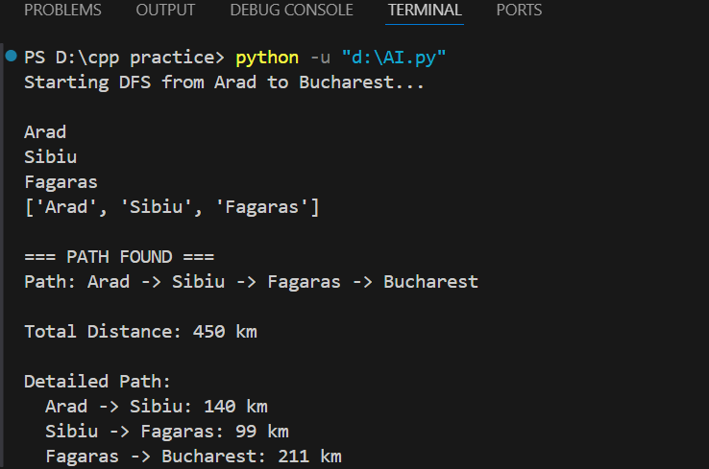

Task 02:

Generate a list of possible words from a character matrix Given an M × N boggle board, find a list of all possible words that can be formed by a sequence of adjacent characters on the board. We are allowed to search a word in all eight possible directions, i.e., North, West, South, East, North East, North-West, South-East, South-West, but a word should not have multiple instances of the same cell. Consider the following the traditional 4 × 4 boggle board. If the input dictionary is [START, NOTE, SAND, STONED], the valid words are [NOTE, SAND, STONED]. Boggle Board

Code:

class Node:
def __init__(self, state, parent, actions, letter):
self.state = state # (row, col) position
self.parent = parent
self.actions = actions # possible next positions
self.letter = letter

def findWords():
# Boggle board
board = [
['M', 'S', 'E', 'F'],
['R', 'A', 'T', 'D'],
['L', 'O', 'N', 'E'],
['K', 'A', 'F', 'B']
]

# Dictionary of valid words
dictionary = ['START', 'NOTE', 'SAND', 'STONED', 'TONE', 'STONE', 'STON', 'NOT']

rows = len(board)
cols = len(board[0])

# All 8 directions: N, S, E, W, NE, NW, SE, SW
directions = [
(-1, 0), # North
(1, 0), # South
(0, 1), # East
(0, -1), # West
(-1, 1), # North-East
(-1, -1), # North-West
(1, 1), # South-East
(1, -1) # South-West
]

foundWords = []

# Start DFS from each cell
for i in range(rows):
for j in range(cols):
# For each starting position, try to find words
DFS(board, i, j, "", set(), dictionary, foundWords, directions, rows, cols)

return foundWords

def DFS(board, row, col, currentWord, visited, dictionary, foundWords, directions, rows, cols):
# Add current position to visited
visited.add((row, col))
currentWord += board[row][col]

# Check if current word is in dictionary
if currentWord in dictionary and currentWord not in foundWords:
foundWords.append(currentWord)
print(f"Found word: {currentWord}")

# Explore all 8 directions
for dr, dc in directions:
newRow = row + dr
newCol = col + dc

# Check if new position is valid
if (0 <= newRow < rows and
0 <= newCol < cols and
(newRow, newCol) not in visited):

# Check if continuing could lead to a valid word
# (optimization: only continue if some word starts with currentWord)
newWord = currentWord + board[newRow][newCol]
if anyWordStartsWith(newWord, dictionary):
DFS(board, newRow, newCol, currentWord, visited.copy(),
dictionary, foundWords, directions, rows, cols)

def anyWordStartsWith(prefix, dictionary):
"""Check if any word in dictionary starts with given prefix"""
for word in dictionary:
if word.startswith(prefix):
return True
return False

def printBoggleBoard(board):
"""Print the boggle board in a nice format"""
print("\n=== BOGGLE BOARD ===")
for row in board:
print(" ".join(row))
print()

# Main execution
print("Starting Boggle Word Finder...\n")

board = [
['M', 'S', 'E', 'F'],
['R', 'A', 'T', 'D'],
['L', 'O', 'N', 'E'],
['K', 'A', 'F', 'B']
]

printBoggleBoard(board)

print("Searching for words...\n")
foundWords = findWords()

print("\n=== RESULTS ===")
print(f"Total words found: {len(foundWords)}")
print(f"Words: {foundWords}")

Output:

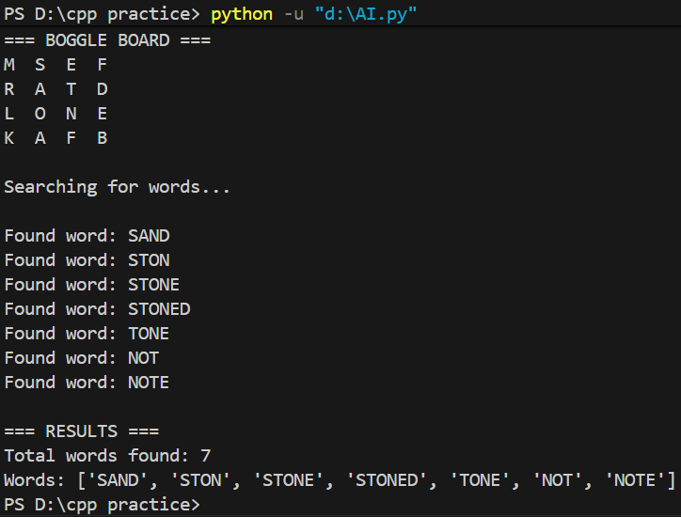

Lab tasks 05

Task 01:
Imagine going from Arad to Bucharest in the following map. Your goal is to minimize the distance mentioned in the map during your travel. Implement a iterative deepening search to find the corresponding path.

Code:
class Node:
def __init__(self, state, parent, actions, distance):
self.state = state
self.parent = parent
self.actions = actions
self.distance = distance

def IDS():
initialState = 'Arad'
goalState = 'Bucharest'

# Graph as a dictionary where each node has state, parent, actions (neighbors), distance
graph = {
'Arad': Node('Arad', None, ['Zerind', 'Timisoara', 'Sibiu'], None),
'Zerind': Node('Zerind', None, ['Arad', 'Oradea'], None),
'Oradea': Node('Oradea', None, ['Zerind', 'Sibiu'], None),
'Timisoara': Node('Timisoara', None, ['Arad', 'Lugoj'], None),
'Lugoj': Node('Lugoj', None, ['Timisoara', 'Mehadia'], None),
'Mehadia': Node('Mehadia', None, ['Lugoj', 'Drobeta'], None),
'Drobeta': Node('Drobeta', None, ['Mehadia', 'Craiova'], None),
'Craiova': Node('Craiova', None, ['Drobeta', 'Rimnicu Vilcea', 'Pitesti'], None),
'Sibiu': Node('Sibiu', None, ['Arad', 'Oradea', 'Rimnicu Vilcea', 'Fagaras'], None),
'Rimnicu Vilcea': Node('Rimnicu Vilcea', None, ['Sibiu', 'Craiova', 'Pitesti'], None),
'Fagaras': Node('Fagaras', None, ['Sibiu', 'Bucharest'], None),
'Pitesti': Node('Pitesti', None, ['Rimnicu Vilcea', 'Craiova', 'Bucharest'], None),
'Bucharest': Node('Bucharest', None, ['Fagaras', 'Pitesti', 'Giurgiu', 'Urziceni'], None),
'Giurgiu': Node('Giurgiu', None, ['Bucharest'], None),
'Urziceni': Node('Urziceni', None, ['Bucharest', 'Hirsova', 'Vaslui'], None),
'Hirsova': Node('Hirsova', None, ['Urziceni', 'Eforie'], None),
'Eforie': Node('Eforie', None, ['Hirsova'], None),
'Vaslui': Node('Vaslui', None, ['Urziceni', 'Iasi'], None),
'Iasi': Node('Iasi', None, ['Vaslui', 'Neamt'], None),
'Neamt': Node('Neamt', None, ['Iasi'], None)
}

# Distance mapping between cities
distances = {
('Arad', 'Zerind'): 75, ('Zerind', 'Arad'): 75,
('Arad', 'Timisoara'): 118, ('Timisoara', 'Arad'): 118,
('Arad', 'Sibiu'): 140, ('Sibiu', 'Arad'): 140,
('Zerind', 'Oradea'): 71, ('Oradea', 'Zerind'): 71,
('Oradea', 'Sibiu'): 151, ('Sibiu', 'Oradea'): 151,
('Timisoara', 'Lugoj'): 111, ('Lugoj', 'Timisoara'): 111,
('Lugoj', 'Mehadia'): 70, ('Mehadia', 'Lugoj'): 70,
('Mehadia', 'Drobeta'): 75, ('Drobeta', 'Mehadia'): 75,
('Drobeta', 'Craiova'): 120, ('Craiova', 'Drobeta'): 120,
('Craiova', 'Rimnicu Vilcea'): 146, ('Rimnicu Vilcea', 'Craiova'): 146,
('Craiova', 'Pitesti'): 138, ('Pitesti', 'Craiova'): 138,
('Sibiu', 'Rimnicu Vilcea'): 80, ('Rimnicu Vilcea', 'Sibiu'): 80,
('Sibiu', 'Fagaras'): 99, ('Fagaras', 'Sibiu'): 99,
('Rimnicu Vilcea', 'Pitesti'): 97, ('Pitesti', 'Rimnicu Vilcea'): 97,
('Fagaras', 'Bucharest'): 211, ('Bucharest', 'Fagaras'): 211,
('Pitesti', 'Bucharest'): 101, ('Bucharest', 'Pitesti'): 101,
('Bucharest', 'Giurgiu'): 90, ('Giurgiu', 'Bucharest'): 90,
('Bucharest', 'Urziceni'): 85, ('Urziceni', 'Bucharest'): 85,
('Urziceni', 'Hirsova'): 98, ('Hirsova', 'Urziceni'): 98,
('Urziceni', 'Vaslui'): 142, ('Vaslui', 'Urziceni'): 142,
('Hirsova', 'Eforie'): 86, ('Eforie', 'Hirsova'): 86,
('Vaslui', 'Iasi'): 92, ('Iasi', 'Vaslui'): 92,
('Iasi', 'Neamt'): 87, ('Neamt', 'Iasi'): 87
}

# Iterative Deepening: Start with depth 0 and increase
maxDepth = 0
found = False

while not found:
print(f"\n{'='*50}")
print(f"Searching at depth limit: {maxDepth}")
print(f"{'='*50}")

# Reset parent pointers for each iteration
for key in graph:
graph[key].parent = None

result = depthLimitedSearch(graph, initialState, goalState, maxDepth, distances)

if result == "found":
print("\n*** GOAL FOUND! ***")
return actionSequence(graph, initialState, goalState, distances)
elif result == "cutoff":
print(f"Depth {maxDepth} completed - No solution found, trying deeper...")
maxDepth += 1
else:
print("No solution exists")
return None

def depthLimitedSearch(graph, initialState, goalState, limit, distances):
frontier = [(initialState, 0)] # (state, depth)
explored = []
cutoffOccurred = False

while len(frontier) != 0:
currentNode, depth = frontier.pop(len(frontier) - 1)
print(f" Exploring: {currentNode} (depth: {depth})")

if currentNode == goalState:
return "found"

explored.append(currentNode)

if depth < limit:
currentChildren = 0
for child in graph[currentNode].actions:
if child not in explored:
graph[child].parent = currentNode
currentChildren += 1
frontier.append((child, depth + 1))

if currentChildren == 0:
if len(explored) > 0:
del explored[len(explored) - 1]
else:
# Reached depth limit
cutoffOccurred = True

if cutoffOccurred:
return "cutoff"
else:
return "failure"

def actionSequence(graph, initialState, goalState, distances):
"""Trace back path from goal to initial state and calculate total distance"""
sequence = []
totalDistance = 0
state = goalState

while state != initialState:
parent = graph[state].parent
sequence.append(state)
# Get distance between current state and parent
if (parent, state) in distances:
totalDistance += distances[(parent, state)]
state = parent

sequence.append(initialState)
sequence.reverse()

print("\n" + "="*50)
print("=== SOLUTION FOUND ===")
print("="*50)
print(f"Path: {' -> '.join(sequence)}")
print(f"\nTotal Distance: {totalDistance} km")

print("\nDetailed Path:")
for i in range(len(sequence) - 1):
city1, city2 = sequence[i], sequence[i + 1]
dist = distances.get((city1, city2), 0)
print(f" {city1} -> {city2}: {dist} km")

return sequence

# Run Iterative Deepening Search
print("Starting Iterative Deepening Search from Arad to Bucharest...")
print("="*50)
path = IDS()

Output:
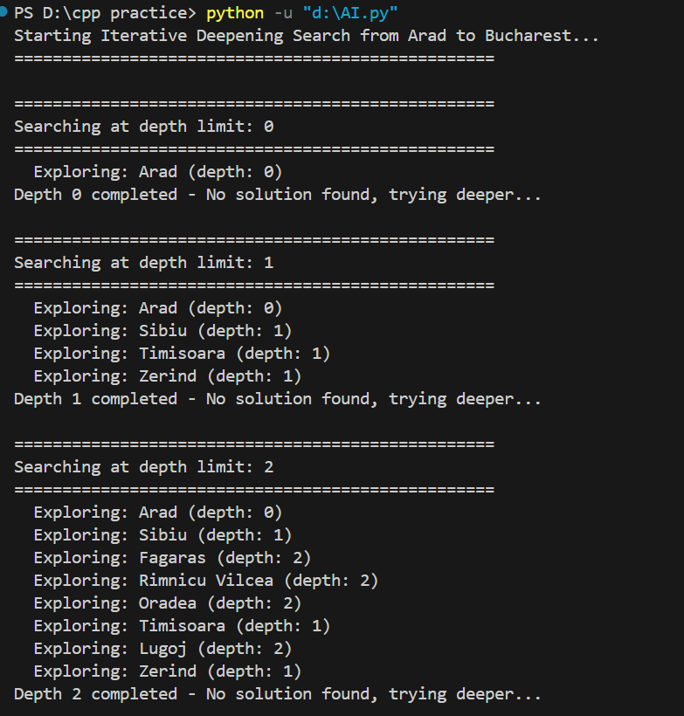
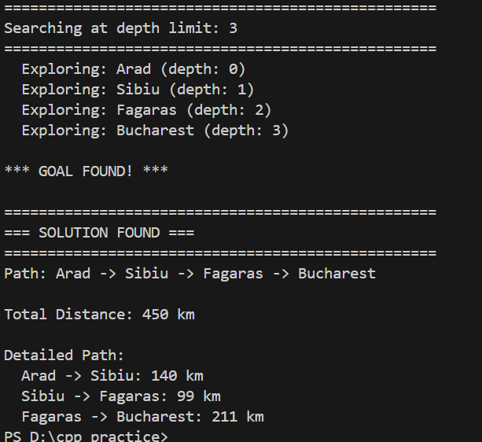

Task 02:
Generate a list of possible words from a character matrix Given a 8 × 8 boggle board, find a list of all possible words that can be formed by a sequence of adjacent characters on the board. We are allowed to search a word in all eight possible directions, i.e., North, West, South, East, North-East, North-West, South-East, South-West, but a word should not have multiple instances of the same cell. Consider the following the traditional 4 × 4 boggle board. If the input dictionary is [START, NOTE, SAND, STONED], the valid words are [NOTE, SAND, STONED]. With iterative deepening, create words of length 5, 6, 7 and 8 through each iteration.
Code:
class Node:
def __init__(self, state, parent, actions, letter):
self.state = state # (row, col) position
self.parent = parent
self.actions = actions # possible next positions
self.letter = letter

def findWordsIDS():
# Boggle board
board = [
['M', 'S', 'E', 'F'],
['R', 'A', 'T', 'D'],
['L', 'O', 'N', 'E'],
['K', 'A', 'F', 'B']
]

# Dictionary of valid words
dictionary = ['START', 'NOTE', 'SAND', 'STONED']

rows = len(board)
cols = len(board[0])

# All 8 directions: N, S, E, W, NE, NW, SE, SW
directions = [
(-1, 0), # North
(1, 0), # South
(0, 1), # East
(0, -1), # West
(-1, 1), # North-East
(-1, -1), # North-West
(1, 1), # South-East
(1, -1) # South-West
]

foundWords = []

print("Starting Iterative Deepening Search for Boggle Words...")
print("="*60)
printBoggleBoard(board)

# Iterative Deepening: Search for words of length 5, 6, 7, 8
for targetLength in range(5, 9):
print(f"\n{'='*60}")
print(f"SEARCHING FOR WORDS OF LENGTH: {targetLength}")
print(f"{'='*60}")

# Start from each cell
for i in range(rows):
for j in range(cols):
depthLimitedDFS(board, i, j, "", set(), dictionary,
foundWords, directions, rows, cols,
targetLength, 0)

return foundWords

def depthLimitedDFS(board, row, col, currentWord, visited, dictionary,
foundWords, directions, rows, cols, depthLimit, currentDepth):
"""DFS with depth limit for iterative deepening"""

# Add current position to visited
visited.add((row, col))
currentWord += board[row][col]
currentDepth += 1

# Check if we reached the depth limit
if currentDepth == depthLimit:
# Check if current word is in dictionary
if currentWord in dictionary and currentWord not in foundWords:
foundWords.append(currentWord)
print(f" ✓ Found word: {currentWord} (length: {len(currentWord)})")
printPath(visited, board)
visited.remove((row, col))
return

# If not at depth limit, explore neighbors
if currentDepth < depthLimit:
# Check if continuing could lead to a valid word
if not anyWordStartsWith(currentWord, dictionary):
visited.remove((row, col))
return

# Explore all 8 directions
for dr, dc in directions:
newRow = row + dr
newCol = col + dc

# Check if new position is valid
if (0 <= newRow < rows and
0 <= newCol < cols and
(newRow, newCol) not in visited):

depthLimitedDFS(board, newRow, newCol, currentWord,
visited.copy(), dictionary, foundWords,
directions, rows, cols, depthLimit, currentDepth)

visited.remove((row, col))

def anyWordStartsWith(prefix, dictionary):
"""Check if any word in dictionary starts with given prefix"""
for word in dictionary:
if word.startswith(prefix):
return True
return False

def printBoggleBoard(board):
"""Print the boggle board in a nice format"""
print("BOGGLE BOARD:")
print(" " + "-" * 17)
for row in board:
print(" | " + " | ".join(row) + " |")
print(" " + "-" * 17)
print()

def printPath(visited, board):
"""Print the path taken to form the word"""
sortedPath = sorted(list(visited))
pathStr = " -> ".join([f"{board[r][c]}({r},{c})" for r, c in sortedPath])
print(f" Path: {pathStr}")

# Main execution
print("\n" + "="*60)
print("BOGGLE WORD FINDER - ITERATIVE DEEPENING SEARCH")
print("="*60 + "\n")

board = [
['M', 'S', 'E', 'F'],
['R', 'A', 'T', 'D'],
['L', 'O', 'N', 'E'],
['K', 'A', 'F', 'B']
]

foundWords = findWordsIDS()

print("\n" + "="*60)
print("=== FINAL RESULTS ===")
print("="*60)
print(f"Total words found: {len(foundWords)}")
print(f"Words by length:")
for length in range(5, 9):
wordsOfLength = [w for w in foundWords if len(w) == length]
if wordsOfLength:
print(f" Length {length}: {wordsOfLength}")

print(f"\nAll words found: {foundWords}")
print("="*60)

Output:

